**LEBANESE AMERICAN UNIVERSITY**

**USAID – HIGHER EDUCATION SCHOLARSHIP PROGRAM**

**HES - Volunteering Program Verification Form**

This form is to be used to document volunteering hours. If a student volunteers for multiple organizations, a separate form must be used for each organization. **This form must be turned in by the 28th of each month, the latest.**

I certify that the scholar Sondos Maher Alkousa completed a total of 10 hours of service at InnovaThrive.

The hours were completed hours as per the below:

Hours # 2 (date) _2/12 – 6/12_ (initials of supervisor) __A.K.___

Hours # 3 (date) _9/12 – 13/12_ (initials of supervisor) __A.K.___

Hours # 2 date) _16/12 – 20/12 (initials of supervisor) __A.K.___

Hours # 3 date) _23/12 - 27/12 (initials of supervisor) __A.K.___

Brief description of the activities the scholar performed or participated in:

November Research: Social Impacts of Artificial Intelligence  
  
In November, my research focused on the social impacts of Artificial Intelligence (AI). AI is reshaping many aspects of life, from healthcare to employment, with both positive and negative effects. On the positive side, AI enhances efficiency, automates tasks, and aids decision-making, particularly in sectors like healthcare. However, concerns like job displacement, privacy issues, and AI biases persist. Public perception of AI is divided, with some embracing its benefits and others fearing its negative consequences. The research highlights the need for future work on ethical AI use, transparency, and policies to address challenges like job loss and discrimination. December Research: Blockchain in Financial Transactions: Revolutionizing Banking  
  
In December, my research explored blockchain technology’s impact on financial transactions. Blockchain is a decentralized, secure ledger that enables transparent, tamper-proof transactions without intermediaries like banks. Key features include decentralization and immutability, improving security and reducing costs. The advantages of blockchain include faster, more secure transactions, but challenges like high energy consumption, regulatory uncertainty, and scalability issues remain. Despite these hurdles, blockchain has the potential to transform the banking sector by enhancing transparency, reducing fraud, and enabling faster, more efficient financial transactions.

Written feedback about the scholar’s performance:

Sondos’ research on AI’s social impacts (November) and blockchain in finance (December) was well-rounded. She explored AI’s benefits and challenges, such as job displacement and privacy issues, while emphasizing the need for ethical guidelines. Her work on blockchain highlighted its security and efficiency, along with challenges like energy consumption and scalability, showing a balanced understanding of these technologies.

Please rate the overall performance of the scholar at your organization:

|  |  |  |  |
| --- | --- | --- | --- |
|  | Mastery (5) | Proficient (3) | Emerging (1) |
| **Problem solver** | X |  |  |
| **Engaged & Committed** | X |  |  |
| **Open-minded & multicultural** | X |  |  |

Signature

& stamp

__________________________

_

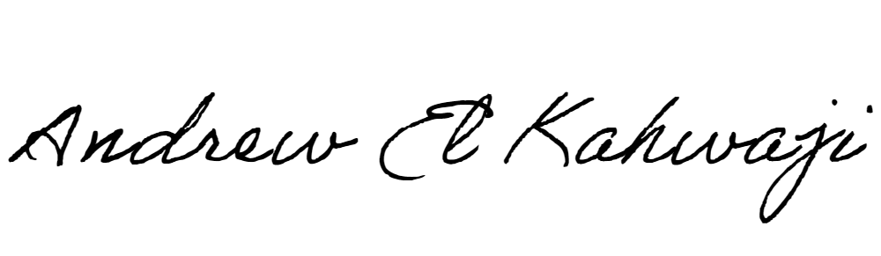

Printed Name _Andrew El Kahwaji_

Date __26/12/2024___

Email __andrew.lifesculptor.coo@gmail.com __

Phone __+961 71 914 378__